PLAY

CONTROLS

CREDITS

EXIT

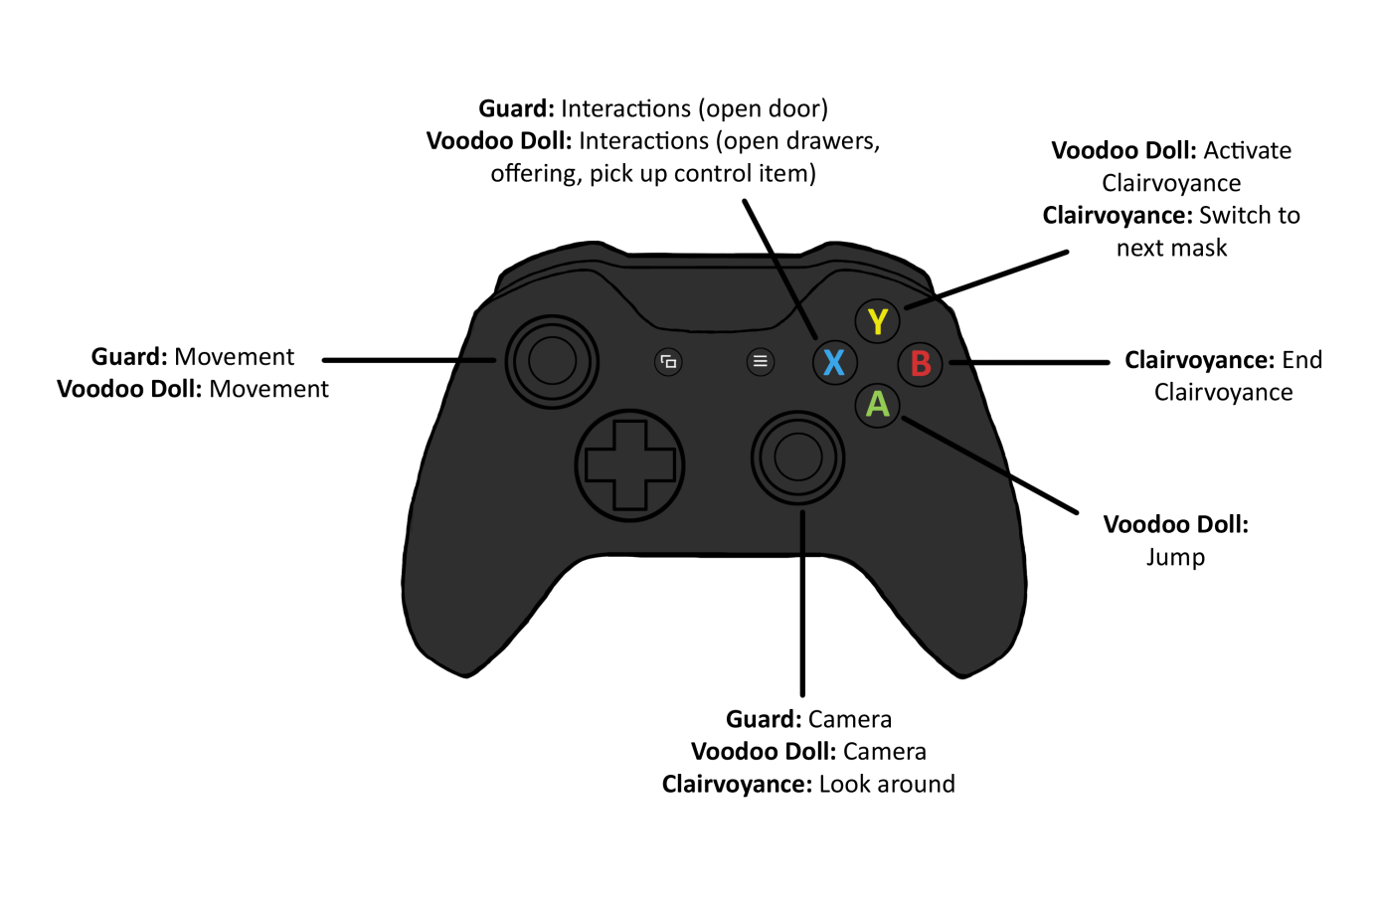

Return

CREDITS:

|  |  |  |
| --- | --- | --- |
| Production |  | Sonja Köck |
| Game Design |  | Tobias Connor Schuster |
| Art Lead |  | Marlou Nolting |

Return